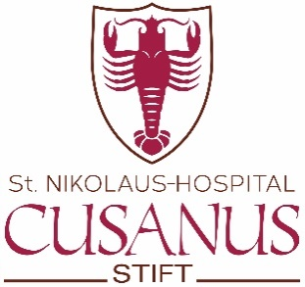

ST. NIKOLAUS-HOSPITAL/CUSANUSSTIFT

For the study of the manuscripts, documents, files etc. in the library or archive of the St. Nikolaus-Hospital/Cusanusstift the following terms & conditions apply:

- A written request must be addressed to the Rector (request form on flip side of this form)
- Detailed explanation of the research purpose
- A referee and the identify number on your passport are needed.
- Lending and copying is not allowed
- Adherence to the terms of reference
- The user is liable for any damage caused by him/her
- The usage of the library/archive is free of charge. The user commits himself to send a free copy of the publication for which the studies were undertaken.

___________________________________________________________________
Cusanusstr. 2 D-54470 Bernkastel-Kues Tel. +49 6531–2260 E-Mail: info@cusanus.de

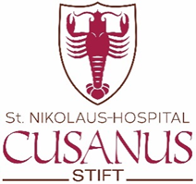
St. Nikolaus-Hospital/Cusanusstift
Rector Leo Hofmann
Cusanusstr. 2
D-54470 Bernkastel-Kues
Germany

Request to study manuscripts, documents, files etc. from the
St. Nikolaus-Hospital/Cusanusstift

Name of applicant:__________________________________________________

Title/Position/Institution:______________________________________________

Address:__________________________________________________________

Phone number:________________ Fax: ______________E-Mail:_____________

Identity number (passport):____________________________________________

Referee:___________________________________________________________

Manuscripts, documents, files etc.: ______________________________________

__________________________________________________________________

Purpose of the research:______________________________________________

Requested date: _____________________________________________________

I accept the terms and conditions on the back side of this form

Signature: ________________________ Date: ___________

